DAT 520 - FINAL PROJECT

1. **Introduction**

The Affordable Care Act (ACA) is a healthcare reform law and among its many goals are to provide people with quality affordable health care while controlling healthcare spending in the U.S. It established the Readmissions Reduction Program (RRP) requiring the Center for Medicare and Medicaid Services (CMS) to reduce payments to hospitals with excess readmissions. (CMS.gov). Avoidable readmissions are one of the problems affecting the healthcare system and costs Medicare $15 billion per year (Brown, B.). The program requires hospitals to publicly report their 30-day readmission rates for certain disease conditions and will penalize hospitals with high rates of readmission. A chartbook prepared by the CMS looked at the prevalence of chronic conditions among Medicare beneficiaries and the impact of chronic conditions on Medicare service utilization and spending. It noted that these patient population are the heaviest users of health care services and accounted for 55% of total Medicare spending on hospitalizations (CMS, 2012). Chronic conditions are long-lasting, slow progressing, ongoing diseases that can be controlled but not cured. The four main types are cardiovascular diseases (like heart attacks and stroke), cancers, chronic respiratory diseases (such as chronic obstructed pulmonary disease and asthma) and diabetes (WHO, 2014).

Both the government and health care providers aim to work together to provide high value care with lower cost. However, on one side, health care providers want to be fully reimbursed for health service provision, but on the other side, Medicare wants to reduce health care spending. With the fee-for-service model where providers are reimbursed for the services they provide, or in some cases, defensive medicine, the practice leans towards performing high volume of tests and services, regardless of whether those services improve quality or contribute to a broader effort to manage care (BPC, 2012). Medicare is now asking the healthcare provider for more evidence of quality and necessity of care to justify reimbursement.

1. **Research Question**

A healthcare organization is planning to implement a chronic disease management program for its Medicare constituents. The target conditions have been narrowed down to 5 chronic conditions, diabetes, congestive heart failure (CHF), asthma, chronic obstructive pulmonary disease (COPD) and hypertension. Due to resource constraints, the plan is to start one program at a time, with an estimated 3 month development for each program. The question is which of these programs will be most valuable to implement first? Corollary to that is the development sequence for which program will be built next until all 5 programs are completed.

1. **Methods**

**Data Source**

Data comes from several public sources. Chronic condition reports based upon CMS administrative enrollment and claims data for Medicare beneficiaries enrolled in the fee-for-service program for 2012 are available from the CMS Chronic Condition Data Warehouse (CCW), [www.ccwdata.org](http://www.ccwdata.org). Data also came from HCUPnet, a free, on-line query system based on data from the Healthcare Cost and Utilization Project (HCUP). It provides access to health statistics and information on hospital inpatient and emergency department utilization. Another source is nonprofit news service, Kaiser Health News. See Appendix B: Public DataSets for details.

The CMS datasets were used as is, capturing only the Illinois values. For the readmission ratios, rows from the KHN data with status of “too few cases to evaluate” were not included in the analysis.

**Study Population**

The target population are Illinois fee-for-service Medicare beneficiaries of all ages with the following chronic conditions: diabetes, congestive heart failure (CHF), asthma, chronic obstructive pulmonary disease (COPD) and hypertension.

**Variables**

The variables included are the Medicare spending for these conditions, the prevalence rate among the beneficiaries, readmissions rate and cost, and penalty for excess readmissions.

*Prevalence rate:*

Beneficiaries with a particular condition divided by the total number of beneficiaries in our fee-for-service population, expressed as a percentage. (CMS.gov)

*Per capita spending:*

Total Medicare payments for all Medicare covered services in Parts A and B and is presented per beneficiary (i.e. per capita). (CMS.gov). Both total actual payments and total standardized payments are presented but the study used only the standardized spending. CMS removes geographic differences in payment rates for individual services as a source of variation.

*Readmission rate:*

Readmission is defined as an admission to an acute care hospital for any cause within 30 days of discharge from an acute care hospital. Except when the patient died during the stay, each inpatient stay is classified as an index admission, a readmission, or both. Readmission rates are calculated as the number of readmissions divided by the number of admissions and expressed as a percentage of all admissions. (CMS.gov)

*Excess readmission ratio:*

Risk-adjusted predicted readmissions/risk-adjusted expected readmissions

*Penalty adjustment:*

A complex calculation by CMS which takes into account the aggregate payments for excess readmissions divided by aggregate payments for all discharges. For FY 2013, the higher of these ratio or 0.99 is factored into the penalty. (CMS.gov). Penalties are percentage reductions of the Medicare payments.

1. **Decision Tree**

The variables were selected to know the probability of a condition occurring among the population and cost for the disease. Since penalties are incurred due to readmissions, the rate and cost of readmissions were the next to be included in the tree. The measurable utility is the expected value of the decision tree. The criterion looks at the highest EV for Medicare spending. This equates to reimbursements for providers. The chronic disease management program wants to avoid the readmission penalty that will reduce reimbursements for the organization.

The table below shows the values of each variable:

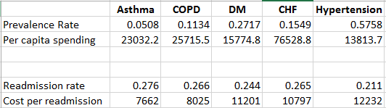

A section of the decision tree model is as shown below, and the file is also embedded in this document. (Appendix C: Decision Tree).

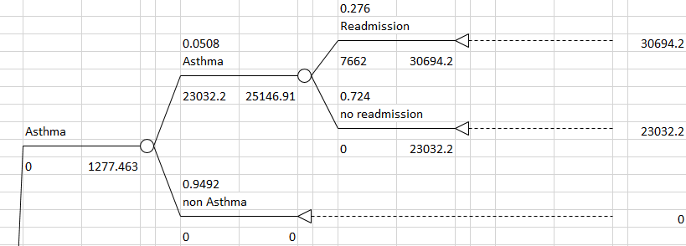

The next event is the penalty cost. Some diseases do not have the penalty event. This is due to the fact that the Readmissions Reduction Program (RRP) only considers 3 conditions (acute myocardial infarction, pneumonia and heart failure), and for FY2015, adding COPD. Hence, in this study, CHF and COPD will have the event for penalties.

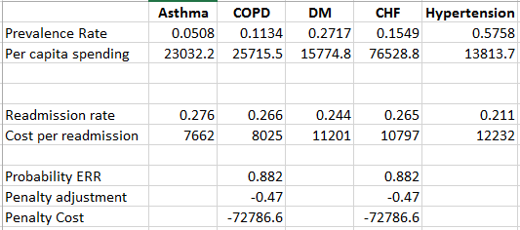

Since COPD data is not yet available, the study uses the same values as the CHF for the penalties. The probability ERR was computed as the number of hospitals in IL with penalties divided by the total number of hospitals. (KHN, Sep 2012, Medicare Readmission Penalties by Hospital). The adjustment factor was the average of all the penalties. Penalty cost is calculated as the adjustment multiplied by the sum of all spending.

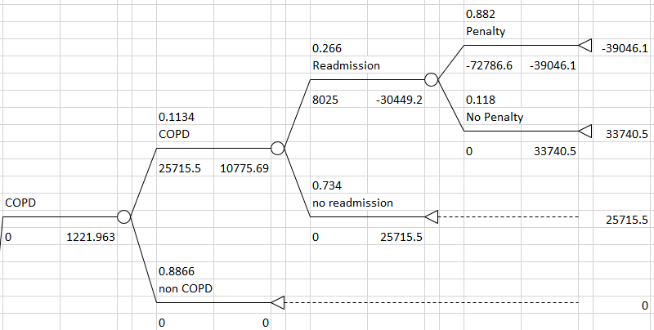

1. **Result**

The result shows the highest EV goes to CHF. It is the optimal strategy of the organization to first implement the CHF program, then hypertension, diabetes, asthma and lastly, COPD.

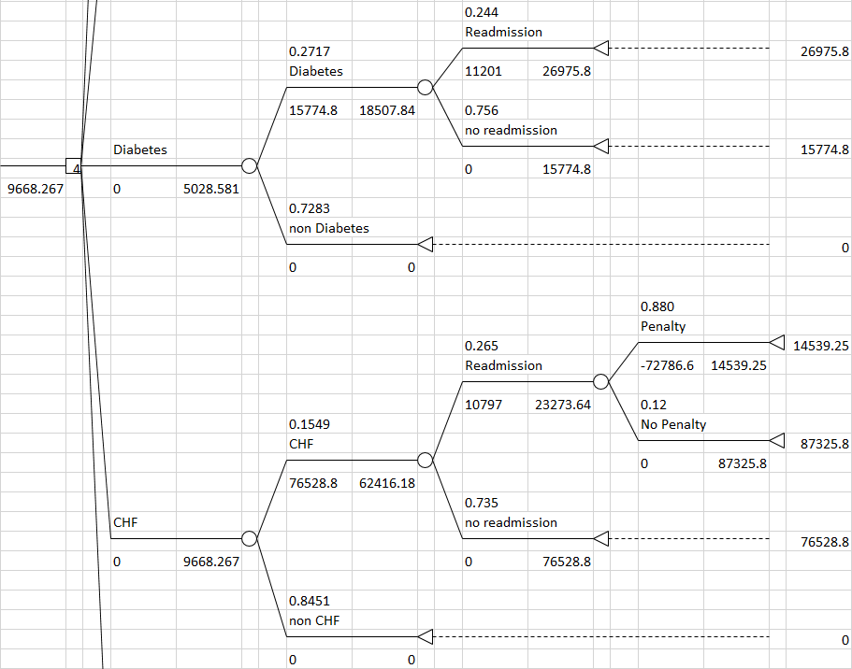

If the decision is judged only by the number of patients, hypertension will win due to a higher prevalence rate than the rest of the diseases. However, taking into account all the other factors like readmissions and penalties, CHF came out as the most optimal strategy.

To see the point at which the strategy would change, and determine how much penalties affect the outcome, a sensitivity analysis of the penalty probabilities and adjustment factors was conducted between CHF and hypertension. If the penalty adjustment is greater than .51, then starting with hypertension becomes more optimal, because the penalty for CHF would be so great that hospitals will incur less reimbursements for the disease.

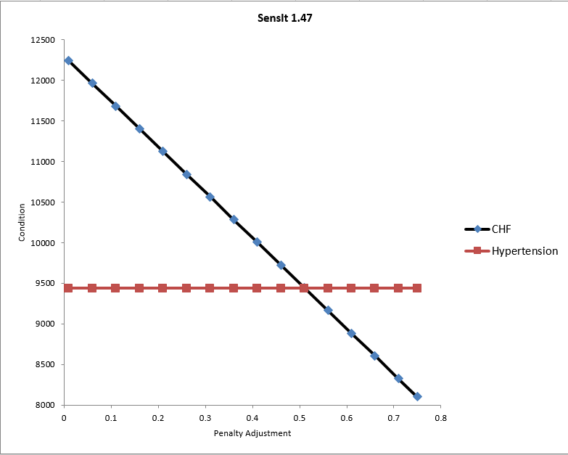

1. **Discussion**

This study addresses the use of decision making tools to assist an organization in deciding when and how to implement programs. Part of the limitation of the study is that it is using public data sets at state-level. Analysis for company projects are confidential and therefore it is not possible to use actual company data. However, the model does describe the approach that the company will take to perform decisions. The model, when used with actual company data, would also reflect best the organization’s current state since it can capture current year versus the public data set used here which is FY2012.

The study is susceptible to the bias of reducing problems into simple constructs. Many factors play a role in Medicare spending/reimbursement. The study only considered penalties but there are new programs that Medicare had been introducing like the Medicare Shared Savings Program (CMS.gov) that incentivizes the provider versus penalizing them. The implementation of this program commenced for FY2012, but CMS has not yet released any public data sets. A good extension to the study would be to include incentive amounts to determine the expected value.

1. **Conclusion**

The model has demonstrated the sequence of how the programs can be implemented. One good approach for the healthcare organization is to reevaluate the model and redo the analysis close to the end of the first program implementation to see if new information would change the sequence of the succeeding four.

**Appendix A: References**

Bipartisan Policy Center (BPC). (2012, Sep). What Is Driving U.S. Health Care Spending? America’s Unsustainable Health Care Cost Growth. Retrieved from <http://bipartisanpolicy.org/sites/default/files/BPC%20Health%20Care%20Cost%20Drivers%20Brief%20Sept%202012.pdf>

Brown, Bobbi. (2014). A Best Way to Manage a CMS Hospital Readmission Reduction Program. Retrieved from <https://www.healthcatalyst.com/healthcare-data-warehouse-hospital-readmissions-reduction>

Centers for Medicare and Medicaid Services. (n.d.). Readmissions Reduction Program. Retrieved from <http://www.cms.gov/Medicare/Medicare-Fee-for-Service-Payment/AcuteInpatientPPS/Readmissions-Reduction-Program.html>

Centers for Medicare and Medicaid Services. (2012). Chronic Conditions among Medicare Beneficiaries, Chartbook, 2012 Edition. Baltimore, MD. Retrieved from <http://www.cms.gov/Research-Statistics-Data-and-Systems/Statistics-Trends-and-Reports/Chronic-Conditions/Downloads/2012Chartbook.pdf>

CMS.gov. (2014). Chronic Conditions. Retrieved from <http://www.cms.gov/Research-Statistics-Data-and-Systems/Statistics-Trends-and-Reports/Chronic-Conditions/CC_Main.html>

CMS.gov. (2014). Shared Savings Program. Retrieved from https://www.cms.gov/Medicare/Medicare-Fee-for-Service-Payment/sharedsavingsprogram/index.html?redirect=/sharedsavingsprogram/

World Health Organization. (2014). Noncommunicable diseases. Retrieved from <http://www.who.int/topics/noncommunicable_diseases/en/>

**Appendix B: Public DataSets**

**Prevalence, readmissions rate and per capita spending**

CMS.gov. (2014, Sep). Chronic Conditions. Retrieved from http://www.cms.gov/Research-Statistics-Data-and-Systems/Statistics-Trends-and-Reports/Chronic-Conditions/CC_Main.html

Utilization/Spending State Level: All Beneficiaries, 2008-2012 [ZIP, 553KB]. Utiliz_Spend_2012.xlsx

Prevalence HRR Level: All Beneficiaries by Age, 2008-2012 [ZIP, 1MB]. HRR_Table_Chronic_Conds_Prevalence_by_Age_2012.xlsx

**Readmission cost**

Healthcare Cost and Utilization Project (HCUP). (2014). Hospital Readmissions. Readmission Summary Tables.

Retrieved from <http://hcupnet.ahrq.gov/HCUPnet.jsp?Id=27B850D0C231FC58&Form=SelDXPR&JS=Y&Action=%3E%3ENext%3E%3E&_DXPR=DCCHPR1>

**Hospital penalties**

Kaiser Health News (KHN). 2012, Oct 2). Medicare Readmission Penalties by Hospital (September Update). Retrieved from http://kaiserhealthnews.org/news/medicare-revises-hospitals-readmissions-penalties/

**Appendix C: Decision Tree**

